Spring Transactions & @Transactional Annotation

What is a Transaction?
A Transaction is a group of operations treated as a single unit of work.
Either:
- All operations succeed
OR
- Everything is rolled back
Transactions guarantee ACID properties.

Why Do We Need Transactions?
Imagine: ✈️ Three users are trying to book the same flight window seat at the same time.
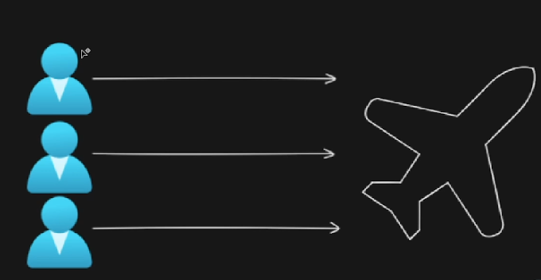
If:
- All three requests update the database
- All three get “Seat Confirmed”
👉 Boarding time = Chaos.
👉 Database = Inconsistent.
👉 Business = Broken.
This is called data inconsistency due to concurrent access.
When multiple requests try to modify the same resource simultaneously, we enter a critical section of code.
What is a Critical Section?
A critical section is a part of code where:
- Shared resources are modified
- Data must remain consistent
- Concurrency can cause corruption
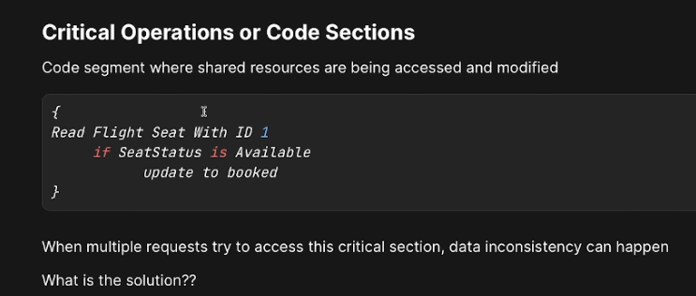
Examples:
- Booking a flight seat , Bank money transfer
- Inventory stock update , Order payment processing
To protect this, we use Transactions.

ACID Properties (Detailed with Bank Example)
Let’s understand using a bank transfer:
You send ₹10,000 to your friend.
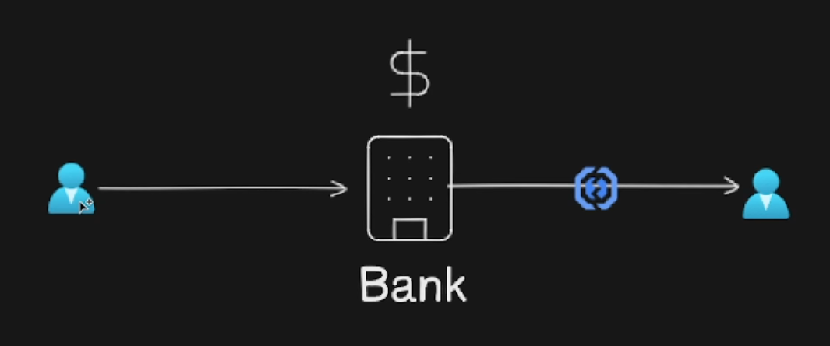
Two operations happen:
- Debit from your account
- Credit to friend’s account
🅰 Atomicity – “All or Nothing”
Definition:
If one operation fails, the entire transaction is rolled back.
Step | Operation | Result
1 | Debit ₹10,000 from you | Success
2 | Credit to friend | ❌ Failed

👉 Without Atomicity → Money deducted but not credited
👉 With Atomicity → Entire transaction rolled back
Your balance remains unchanged.
✅ Ensures partial updates never happen.
🅲 Consistency – “Valid State Always”
Definition:
Database must move from one valid state to another valid state.
Example:
Before transaction:
- Your balance: ₹20,000
- Friend balance: ₹5,000
- Total: ₹25,000
After transfer:
- Your balance: ₹10,000
- Friend balance: ₹15,000
- Total: ₹25,000
👉 Total remains same
👉 No constraint violation
👉 No negative balance
🅸 Isolation – “Transactions Don’t See Each Other’s Mess”
Definition:
Multiple transactions running in parallel should not interfere.
Example:
3 users try booking same seat.
Without Isolation:
- All see seat available
- All book it
With Isolation:
- First transaction locks seat
- Others wait or fail
Prevents:
- Dirty reads
- Non-repeatable reads
- Phantom reads

🅳 Durability – “Once Committed, It’s Permanent”
Definition:
After commit, data will not be lost even if system crashes.
Example:
- Transaction committed
- System crashes
- On restart → Data still exists
Handled by:
- Write-ahead logs
- Database persistence mechanisms

With and Without Transaction
❌ Without Transaction
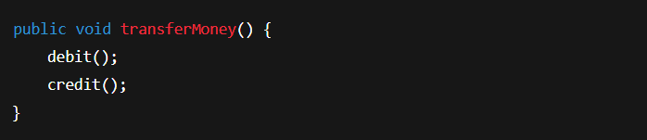If credit fails:
- Debit remains
- System inconsistent
With Transaction
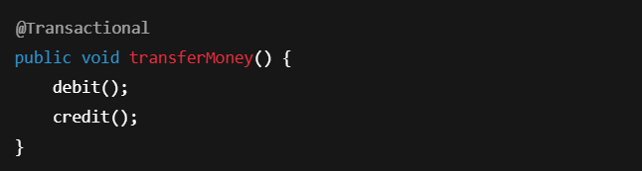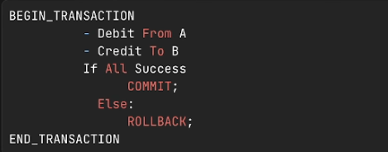
If credit fails:
- Entire transaction rolled back
- No money lost

What is @Transactional?
@Transactional is a Spring annotation that:
👉 Declares a method/class should execute within a database transaction.
Spring will:
- Start transaction
- Executes method
- Commit if success
- Rollback if exception occurs

Why Do We Use @Transactional in Spring Boot?
We use it to:
- Protect critical sections
- Maintain data consistency
- Prevent partial updates
- Ensure ACID compliance
- Handle rollback automatically
Without it:
You must manually manage transaction begin/commit/rollback.
With it:
Spring handles everything.

Where Do We Use @Transactional?
Primarily in:
✅ Service Layer (Business Logic Layer)
Why not Controller?
- Controller handles HTTP
- Service handles business rules
Example use cases:
- Bank transfer
- Order placement
- Booking system
- Stock deduction
- Payment processing

🏗 Required Dependency
spring-boot-starter-data-jpa
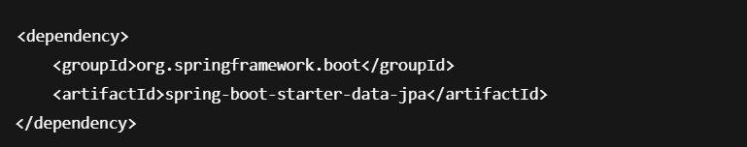

⚙️ How Spring Transaction Management Works (AOP)
Spring uses AOP (Aspect-Oriented Programming).
Flow:
- Proxy created around Service class
- Proxy intercepts method call
- Transaction starts
- Method executes
- If success → Commit
- If exception → Rollback
👉 You never see this code.
👉 Spring handles internally.

🧪 Example: Flight Booking System
Service Class
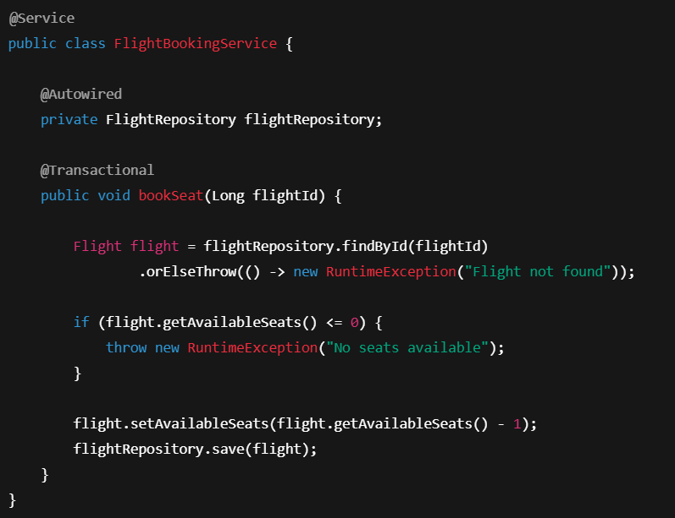

What Happens Internally?
Step 1: Transaction starts
Step 2: Seat count checked
Step 3: Seat reduced
Step 4: If no exception → Commit
If exception → Rollback

🏷 Class-Level vs Method-Level - @Transactional

1️⃣ Method-Level
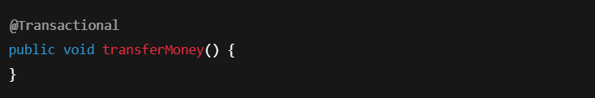
2️⃣ Class-Level
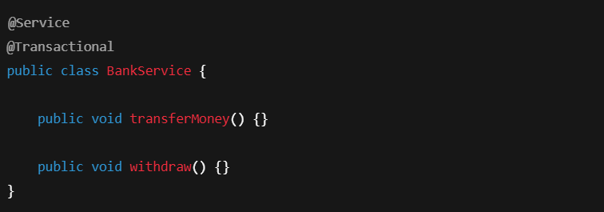👉 All public methods become transactional.

❗ Important Rules
Private Methods
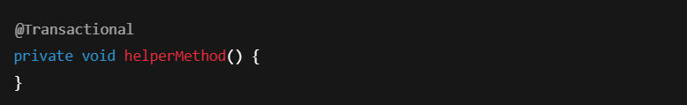❌ WILL NOT WORK
Why?
Because Spring uses proxy.
Private methods are not intercepted.

Class-Level + Private Method
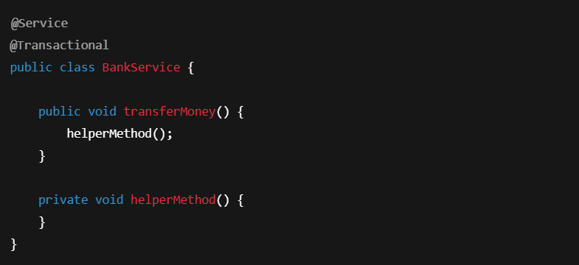
helperMethod()
❌ Not transactional separately
Only public methods via proxy are transactional.

When Will Rollback Happen?
Default Behavior:
Rollback happens only for:
✅ RuntimeException
❌ Not for Checked Exception

Example
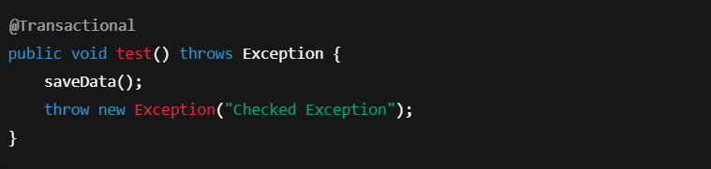👉 Will NOT rollback by default.
Force Rollback
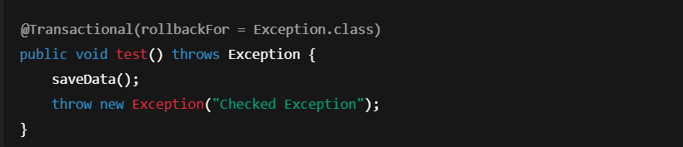Now it will rollback.

What Exactly is a Transaction?
A transaction is:
A logical unit of work that ensures atomicity, consistency, isolation, and durability while modifying database state.

What Exactly is @Transactional?
@Transactional is:
A declarative way to manage transactions in Spring using AOP proxies.
Instead of writing:
- beginTransaction()
- commit()
- rollback()
Spring does it automatically.

Why Is It Very Important?
Because:
Without transactions:
- Double booking
- Money loss
- Inventory corruption
- Data inconsistency
With transactions:
- Safe concurrent operations
- Business reliability
- Production stability

Real-World Use Cases
- Banking systems
- E-commerce checkout
- Airline booking
- Payment gateway
- ERP systems
- Stock trading systems

Interview Questions & Answers

What is a Transaction?
A group of database operations treated as a single unit of work.

What is @Transactional?
Spring annotation is used to declare transaction boundaries declaratively.

Where should we place @Transactional?
In Service layer on business logic methods.

Why not Controller layer?
Controller handles HTTP.
Service handles business rules.

Does @Transactional work on private methods?
No. Because Spring uses proxy-based AOP.

When does rollback happen?
By default on RuntimeException and Error.

How does Spring implement transaction management?
Using AOP proxies.

What happens if one method calls another method in same class?
Internal call bypasses proxy.
Transaction may not apply.

What is propagation?
Defines how transactions behave when called inside another transaction.

What is isolation level?
Defines visibility of changes between transactions.

Final Summary
Transaction:
- Logical unit of work
- Guarantees ACID
@Transactional:
- Declarative transaction management
- Uses AOP proxy
- Applied on Service layer
- Ensures data consistency
- Protects critical sections

